**MVP OnBoard Task with Output**

**a. Display a list of all property names and their property id’s for Owner Id: 1426.**

select op.OwnerId,op.PropertyId,p.Name as PropertyName from Property as p

inner join OwnerProperty as op on p.id=op.PropertyId

**where op.OwnerId=1426**

**OUTPUT**

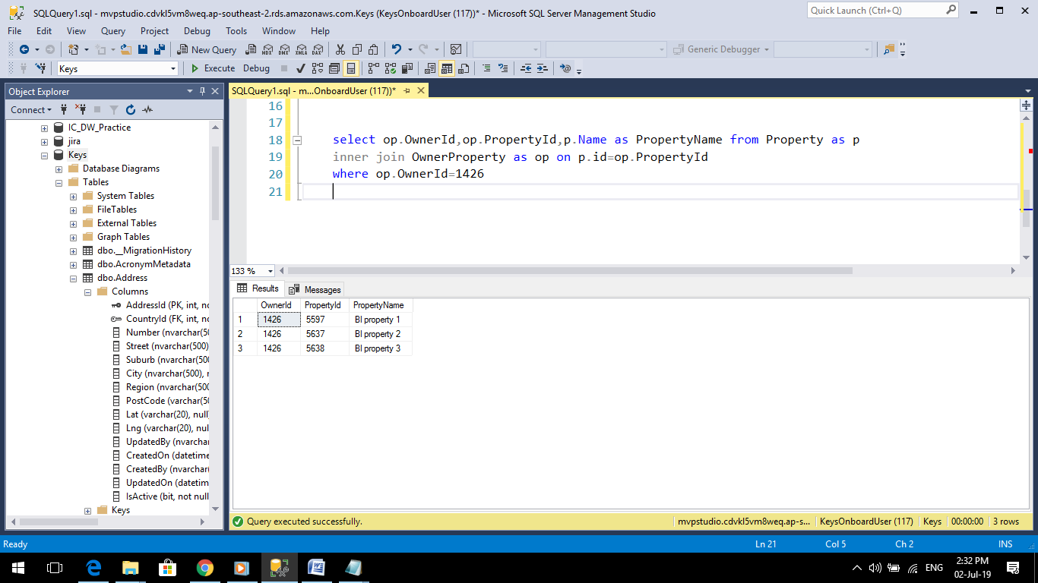

**b. Display the current home value for each property in question a)**

SELECT op.OwnerId,op.PropertyId,p.Name as PropertyName,a.Number +', '+ a.Street +', '+ a.Suburb +', '+ a.City +', '+ a.PostCode as PropertyAddress,phv.Value as HomeValue

FROM Property as p

inner join OwnerProperty as op on p.id=op.PropertyId

inner join Address as a on p.Addressid=a.addressid

inner join PropertyHomeValue as phv on op.PropertyId=phv.PropertyId

WHERE op.OwnerId=1426

**OUTPUT**

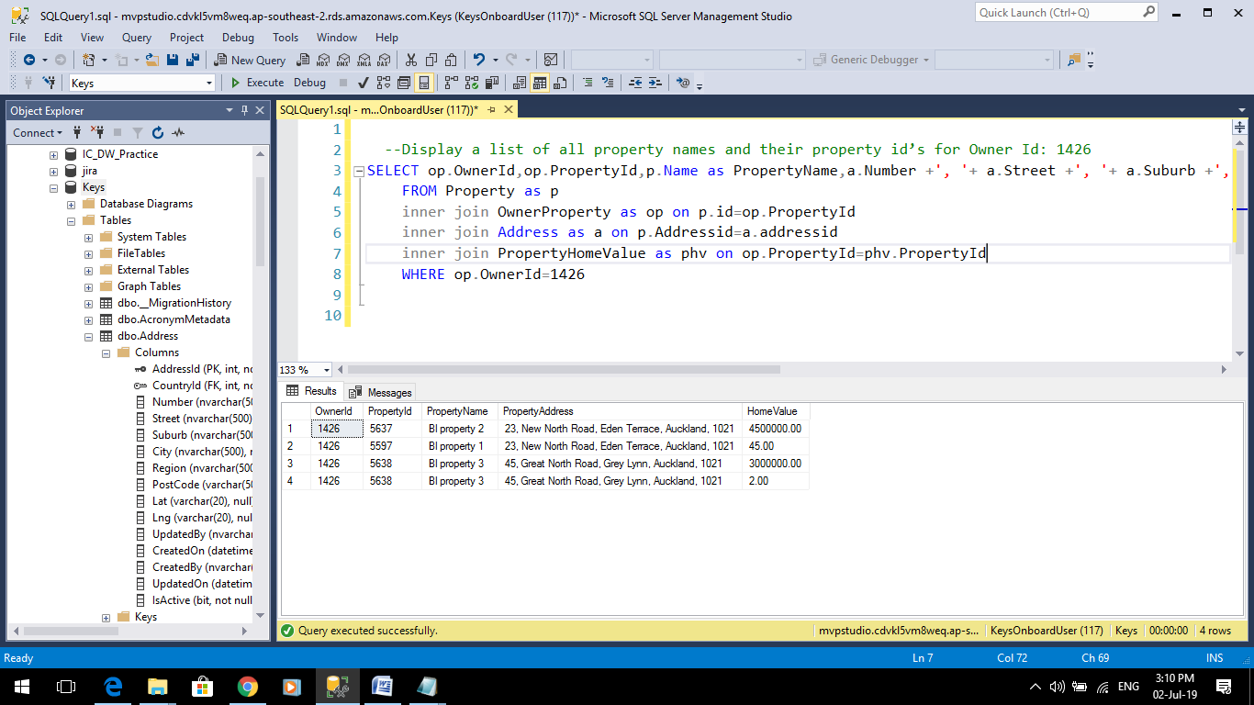

**c. For each property in question a), return the following:**

**(1) Using rental payment amount, rental payment frequency, tenant start date and tenant** **end date to write a query that returns the sum of all payments from start date to end date.**

SELECT

op.OwnerId,op.PropertyId,p.Name as PropertyName

,a.Number +', '+ a.Street +', '+ a.Suburb +', '+ a.City +', '+ a.PostCode as PropertyAddress

,tp.startdate,tp.Enddate

,prp.Amount * datediff(ww,tp.Startdate,tp.Enddate) as SumofAmount

FROM [dbo].[Property] as p

inner join [dbo].[OwnerProperty] as op on p.id=op.PropertyId

inner join [dbo].[Address] as a on p.Addressid=a.addressid

inner join [dbo].[TenantProperty] as tp on op.Propertyid=tp.propertyid

inner join [dbo].[PropertyRentalPayment] as prp on tp.PropertyId=prp.PropertyId

inner join [dbo].[TenantPaymentFrequencies] as tpf on prp.frequencytype=tpf.Id

WHERE op.OwnerId=1426

**OUTPUT**

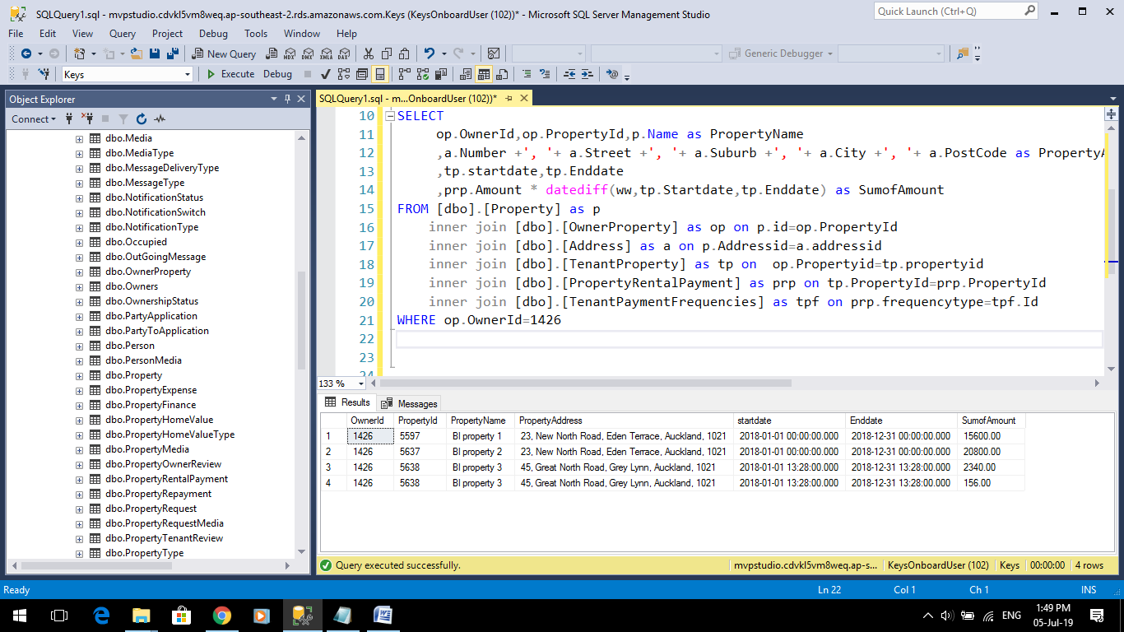

**(2) Display the yield**

SELECT op.OwnerId,op.PropertyId,p.Name as PropertyName,a.Number +', '+ a.Street +', '+ a.Suburb +', '+ a.City +', '+ a.PostCode as PropertyAddress,pf.Yield

FROM Property as p

inner join OwnerProperty as op on p.id=op.PropertyId

inner join Address as a on p.Addressid=a.addressid

inner join propertyfinance as pf on op.propertyid=pf.propertyid

WHERE op.OwnerId=1426

**OUTPUT**

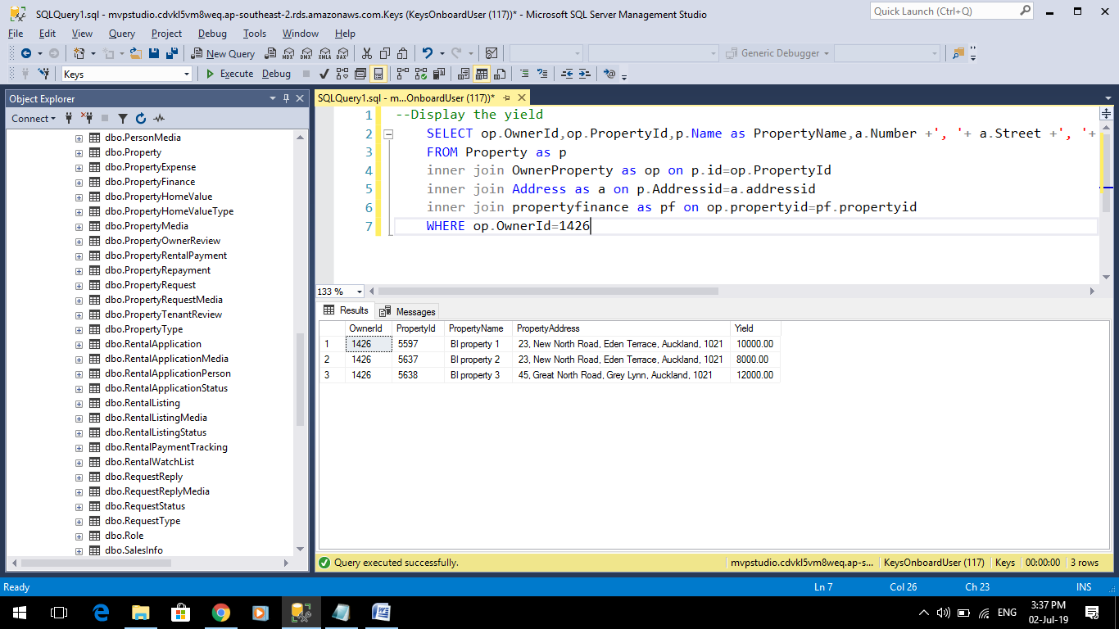

**d. Display all the jobs available in the marketplace (jobs that owners have advertised for service suppliers)**

SELECT j.Propertyid, p.name as PropertyName,j.JobDescription,sp.code as Available

FROM [dbo].[Job] j

inner join [dbo].[ServiceProviderJobStatus] as sp on j.JobStatusId=sp.Id

inner join [dbo].[Property] as p on j.Id=p.Id

WHERE J.JobStatusId=1

**OUTPUT**

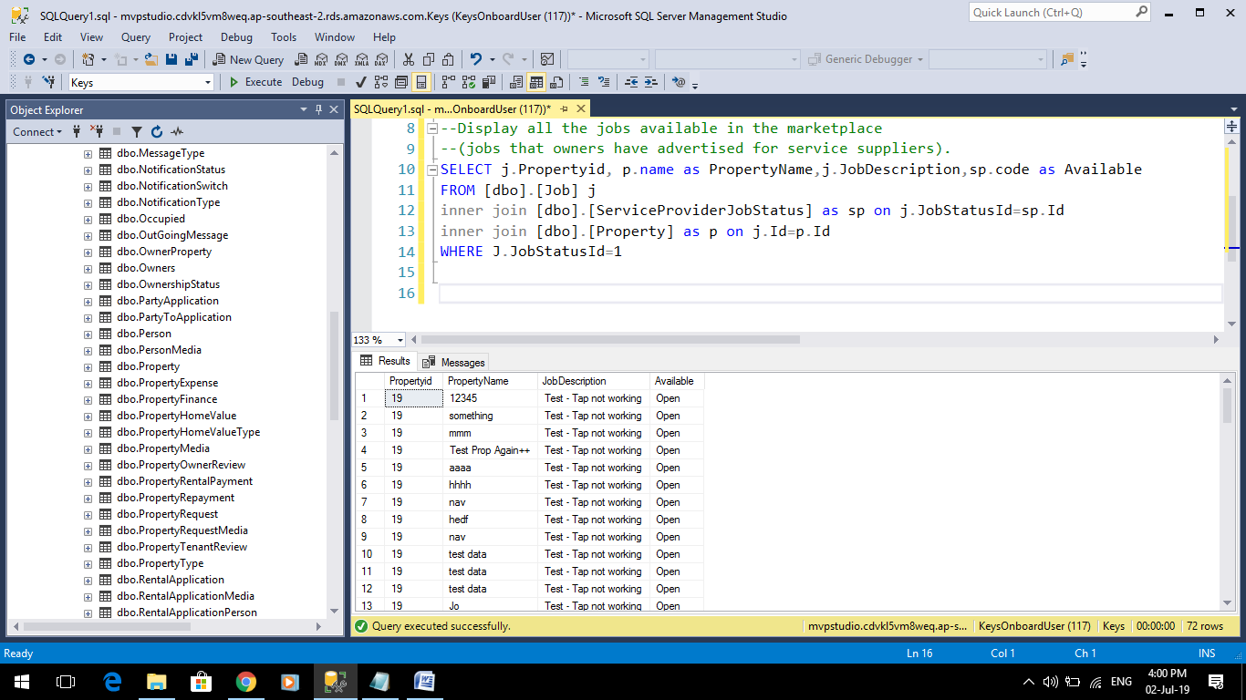

**e. Display all property names, current tenants first and last names and**

**rental payments per week/ fortnight/month for the properties in question a)**

SELECT prop.name as PropertyName,per.FirstName as TenantFirstName, per.LastName as TenantLastName

,paymentamount/52 as Weekly

,paymentamount/14 as Fortnighly

,paymentamount/12 as Monthly

FROM [dbo].[Person] per

join [dbo].[OwnerProperty] op on per.id=op.OwnerId

join [dbo].[Property]prop on op.propertyId=prop.Id

join tenantproperty tp on op.propertyid=tp.propertyid

WHERE per.Id=1426

**OUTPUT**

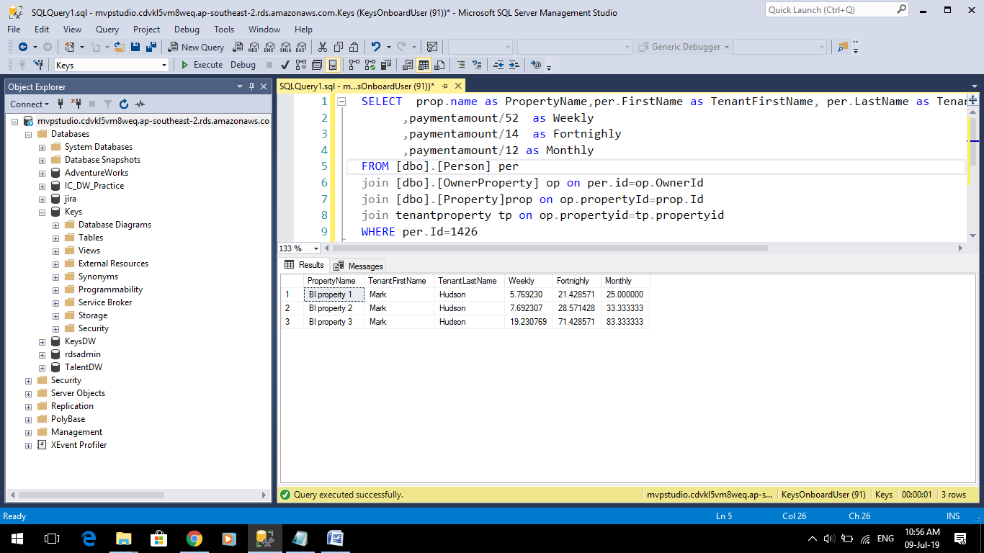

**Stored Procedure for Property_Analysis(Property A)**

ALTER proc [dbo].[usp_property_analysis]

as

select per.FirstName as OwnerName

,p.Name as ProprtyName

,p.Bedroom

,p.Bathroom

,a.Number+','+a.Street+','+a.Suburb+','+a.City+','+a.PostCode as Address

,tp.PaymentAmount

,tpf.name as FrequencyType

,convert(varchar,pe.Date,106) as date

,pe.Description as Expense

from person as per

inner join OwnerProperty as op on per.Id=op.OwnerId

inner join Property as p on p.id=op.PropertyId

inner join address as a on p.AddressId=a.AddressId

inner join TenantProperty as tp on op.PropertyId=tp.PropertyId

inner join TenantPaymentFrequencies as tpf on tp.PaymentFrequencyId=tpf.Id

inner join PropertyExpense as pe on op.PropertyId=pe.PropertyId

where p.name like 'Property A'

**OUTPUT**

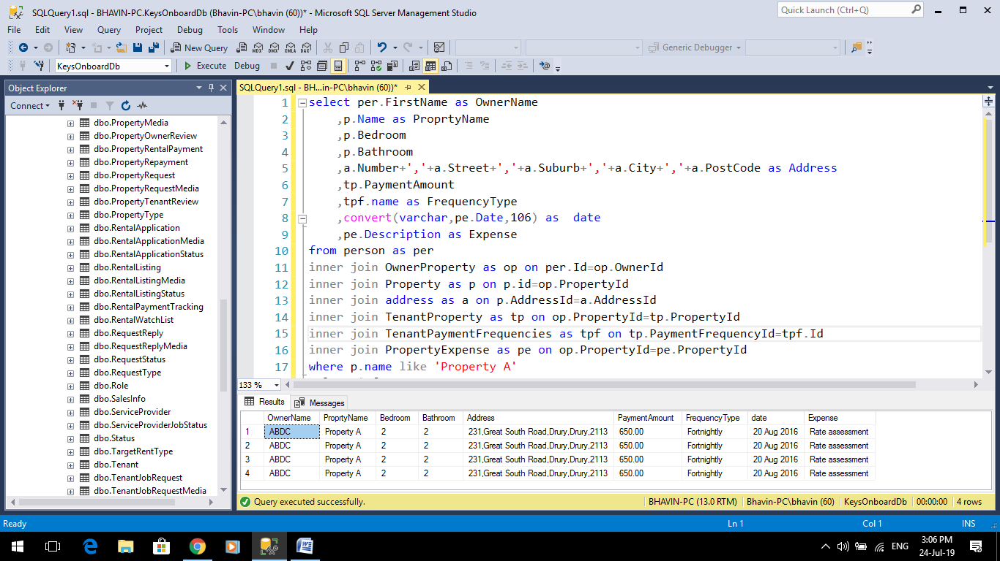

**Report Screenshots(Shows data for the Property A)**

